**EXP NO 22 : CREATE A SIMPLE WEB APPLICATION USING PYTHON AND HOST IT IN MICROSOFT AZURE TO DEMONSTRATE PLATFORM AS A SERVICE (PAAS).**

**AIM:**To create a simple web application using Python and host it in Microsoft Azure to demonstrate Platform as a Service (PaaS).

**PROCEDURE:**

1.Develop a basic Python web application using a lightweight web framework like Flask on your local system.

2. Prepare the necessary deployment files such as a startup command and a requirements list for dependencies.

3. Compress the application files into a .zip archive for easy deployment.

4. Log in to the Azure Portal using your Microsoft account.

5. Create a new App Service by selecting "Create a Resource" and choosing "App Service" from the available options.

6. Configure the App Service by providing details such as resource group name, unique app name, runtime stack (Python), and region.

7. Complete the creation process and wait for Azure to deploy the App Service.

8. Access the newly created App Service and navigate to the Deployment Center.

9. Select Local Git as the deployment method and generate the Git deployment URL.

10. Push your application files to the Azure App Service using Git from your local machine.

11. After successful deployment, open the App Service URL to verify that the web application is running.

**OUTPUT:**

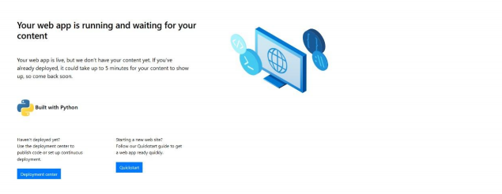

**RESULT:**

A Python web application was successfully created and hosted on Microsoft Azure using App Service, demonstrating the concept of Platform as a Service (PaaS).